 | 12.1.14 Editors - Geometry Nodes Editor - Header - Add Menu - Geometry - Write
Table of content
Detailed table of content 1
Add menu - Geometry - Write 2
Set Geometry Name 2
Set ID 2
Set Position 3

Detailed table of content
Detailed table of content
Detailed table of content 1
Add menu - Geometry - Write 2
Set Geometry Name 2
Inputs 2
Geometry 2
Name 2
Outputs 2
Geometry 2
Set ID 2
Inputs 2
Geometry 2
Selection 2
ID 2
Outputs 3
Geometry 3
Set Position 3
Inputs 3
Geometry 3
Selection 3
Position 3
Offset 3
Outputs 3
Geometry 3

Add menu - Geometry - Write
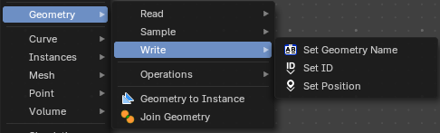
Here you find nodes to modify the geometry.

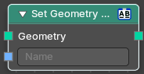
Set Geometry Name
Sets the name of the target geometry.

Inputs

Geometry
Geometry input.

Name
The name that you want to set

Outputs

Geometry
Geometry output.

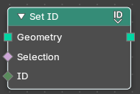
Set ID
Sets the ID of the target geometry.

Inputs

Geometry
Geometry input.

Selection
Selection input.

ID
ID Input

Outputs

Geometry
Geometry output.

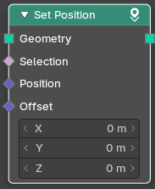
Set Position
The Set Position node controls the location of each point, the same way as controlling the position attribute. If the input geometry contains instances, this node will affect the location of the origin of each instance.
The input node for this data is the Position Node.

Inputs

Geometry
Geometry input.

Selection
Whether or not to change the position of each point or instance. True values mean the position will be changed, false values mean it will remain the same.

Position
The new position for selected elements. By default, this is the same as if the Position Node was connected, meaning the node will do nothing.

Offset
An optional translation for each point. This is evaluated at the same time as the Position input, meaning that fields evaluated for it will not reflect the changed position.

Outputs

Geometry
Geometry outputs.

